**SMART WASTE MANAGEMENT SYSTEM IN METROPOLITAN CITIES USING IOT**

1.19485A0414 (B.Ayyappa swamy)

2.19485A0415 (D.Sivaji)

3.19485A0416 (A.Tarun)

4.19485A0417 (E.Hari babu)

5.19485A0418 (K.Jagadhish)

**TABLE OF CONTENTS**

**1** **INTRODUCTION**

1.1overview

1.2purpose

**2 LITERATURE SURVEY**

2.1Existing problem

2.2Proposed solution

**3 THEORITICAL ANALYSIS**

3.1Blockdiagram

3.2Hardware/software designing

**4 EXPERIMENTAL INVESTIGATION**

**5 FLOW CHART**

**6 RESULT**

**7 ADVANTAGES & DISADVANTAGES**

**8 APPLICATIONS**

**9 CONCLUSION**

**10 FUTURE SCOPE**

**11 BIBLIOGRAPHY**

**APPENDIX**

A. SOURCE CODE

B. UI output screenshot

**1.INTRODUCTION**

**1.1OVERVIEW**

Waste management is all the activities and actions required to manage waste from its inception to its final disposal [1]. This includes collection, transportation, treatment and disposal of waste together with monitoring and regulation. Waste collection methods vary widely among different countries and regions. Domestic waste collection services are often provided by local government authorities.

Curb side collection is the most common method of disposal in most countries, in which waste is collected at regular intervals by specialised trucks. Waste collected is then transported to an appropriate disposal area.

Nowadays, cities with developing economies experience exhausted waste collection services, inadequately managed and uncontrolled dumpsites and the problems are worsening [2]. Waste collection method in such countries is an on-going challenge and many struggle due to weak institutions and rapid urbanization.

**1.2NEED FOR IMPROVEMENT IN WASTE MANAGEMENT SYSTEM**

❖ By 2030, almost two-third of the world’s population will be living in cities. This fact requires the development of sustainable solutions for urban life, managing waste is a key issue for the health.

❖ Efficient and energy-saving waste management, reducing CO2, air pollution and vehicle exhaust emissions—these are just a few examples for the demands of future cities. In views of that, the efficient use and responsible handling of resources become more important.

 Effectively managing waste is important in developed countries. Waste management  may swallow up to 50% of a city’s budget, but only serve a small part of the  population.

❖ Sometimes, up to 60%of waste is not being collected, it is often simply burned by the roadside. It can pollute drinking water; it can spread disease to people living nearby.

❖ Even with great route optimization, the worker must still physically go to the dustbin to check waste levels. Because of this, trucks often visit containers that do not need emptying, which wastes both time and fuel.

❖ Waste management prevents harm to human health and the environment by reducing the volume and hazardous character of residential and industrial waste.

❖ Improving proper waste management will reduce pollution, recycle useful materials and create more green energy.

**2.LITERATURE SURVEY**

**2.1 EXISTING PROBLEM**

An inevitable consequence of development and industrial progress is generation of waste. Therefore, efficient waste management is a matter of international concern and countries have setup robust regulatory waste management regimes for balancing the objectives of development and environment sustainability. In India, the national environment policy, 2006 while suggesting measures for collection of wastes and safe disposal of residues [7].

The metro cities and major economic hubs generate the maximum volume of waste, but a survey of 20 smaller cities selected to be developed as smart cities show that most are struggling to manage waste. So, there should be an improvement in the waste management techniques.

**2.2PROPOSED SOLUTION**

We use a combination of new strategies and technologies to make sure cities are able to categorically sort, recycle and dispose of their waste in a smooth and combo of weight &distance sensors to determine fill level in trash bins to providing garbage truck drivers optimized route suggestions using predictive analytics.

Transform a normal trash bin into a smart bin. A combo reading from ultrasonic sensors placed on the lid of the trash bin and a weight sensor under the bottom panel is used to get an accurate measurement of the weight of the trash stored.

**3.THEORITICAL ANALYSIS**

**3.1BLOCK DIAGRAM**

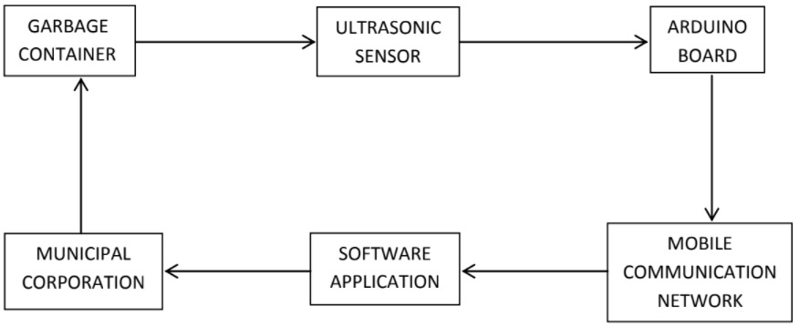

**3.2HARDWARE/SOFTWARE DESIGNING:**

**SOFTWARE DESIGNING:**

By using

* Python
* IOT cloud platform
* FAST2 SMS
* Node RED
* MIT App

**4.EXPERIMENTAL INVESTIGATIONS**:

**5.FLOWCHART:**

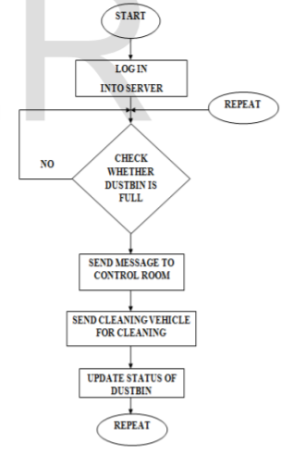

**6.RESULT**

**Python code:**

**3.1 PROGRAM FOR WASTE LEVEL SENSING**

#define trigPin 12

#define echoPin 13

void setup()

{

Serial.begin (9600);

pinMode(trigPin, OUTPUT);

pinMode(echoPin, INPUT);

}

void loop()

{

long duration, distance;

int max = 80; // Let consider as Height of the Garbage Bin is = 80 cm.

float diff, perc;

digitalWrite(trigPin, LOW);

delayMicroseconds(2);

digitalWrite(trigPin, HIGH);

delayMicroseconds(10);

digitalWrite(trigPin, LOW);

duration = pulseIn(echoPin, HIGH);

distance = (duration/2) / 29.1;

diff = max - distance; // 'diff' variable tells u that, how much the Garbage Bin is Left

to fill.

perc = (diff/max)*100; // 'perc' variable tells u that, how much percentage the

Garbage Bin is filled.

if (perc>=90)

{

Serial.println("Garbage Bin is FULL."); // When the Garbage Bin is filled more than 90%, then this Error

Message will Displayed.

}

else

{

Serial.print("Garbage Bin is Filled ");

Serial.print(perc);

Serial.println(" %."); // These 3 Lines are print, that how much the Garbage Bin is Filled...Ex. "Garbage

Bin is Filled 70%.".

}

/*if (distance >= 400 || distance <= 2)

{

Serial.println("Out of range");

}

else

{

Serial.print(distance);

Serial.println(" cm");

}

*/

delay(500);

}3.2 PROGRAM FOR MESSAGE SENDING

SoftwareSerial mySerial(9, 10);

#define trigPin 12

#define echoPin 13

void setup()

{

mySerial.begin(9600); // Setting the baud rate of GSM Module

Serial.begin (9600);

pinMode(trigPin, OUTPUT);

pinMode(echoPin, INPUT);

delay(100);

}

void loop()

{

long duration, distance;

int max = 80; // Let consider as Height of the Garbage Bin is = 80 cm.

float diff, perc;

digitalWrite(trigPin, LOW);

delayMicroseconds(2);

digitalWrite(trigPin, HIGH);

delayMicroseconds(10);

digitalWrite(trigPin, LOW);

duration = pulseIn(echoPin, HIGH);

distance = (duration/2) / 29.1;

diff = max - distance; // 'diff' variable tells u that, how much the Garbage Bin is Left to fill.

perc = (diff/max)*100; // 'perc' variable tells u that, how much percentage the

Garbage Bin is filled.

if (perc>=90)

{

//Serial.println("Garbage Bin is FULL."); // When the Garbage Bin is filled more

than 90%, then this Error Message will Displayed.

// Call the Function of Send SMS.

SendMessage(); // Send Message Function Call.

}

/*

else

{

Serial.print("Garbage Bin is Filled ");

Serial.print(perc);

Serial.print(" %."); // These 3 Lines are print, that how much the Garbage

Bin is Filled...Ex. "Garbage Bin is Filled 70%.".

}

*/

/*

if (distance >= 400 || distance <= 2)

{

Serial.println("Out of range");

}

else

{

Serial.print(distance);

Serial.println(" cm");

}

*/

delay(500);

}

void SendMessage()

{

mySerial.println("AT+CMGF=1"); //Sets the GSM Module in Text Mode

delay(1000); // Delay of 1000 milli seconds or 1 second

mySerial.println("AT+CMGS=\"+918792574742\"\r"); // Replace x with mobile number

delay(1000);

mySerial.println("Garbage Bin is Full."); // The SMS text you want to send

delay(100);

mySerial.println((char)26); // ASCII code of CTRL+Z

delay(1000);

}

3.3 PROGRAM FOR SHORT ROUTE OPTIMIZATION

#include<stdio.h>

#include<stdlib.h>

#define infinity 999

int nd,n=26,v,a[50];

float dist[50];

float

cost[26][26]={999,3.55,4.35,5.85,7.3,7.5,9.45,7.45,6.05,3.45,4.65,6.35,8.8,8.95,10.1,9.55,9.1

5,8.1,6.85,3.3,2.2,3.4,3.7,5.65,6.35,5.1,3.55,999,8.35,2.3,3.7,4.25,5.95,3.75,2.55,2.1,3.33,3.

55,5.1,5.75,6.9,6.75,6.35,5.3,4.05,4.8,3.7,2.7,2.35,4.3,5,4.4,4.35,0.85,999,1.5,2.95,3.4,5.1,2.

9,1.7,2.9,4.1,2.7,4.25,4.9,6.05,5.9,5.5,4.45,3.2,5.6,4.5,3.5,3.15,5.1,5.8,5.45,5.85,3.2,1.5,999,

1.45,1.9,3.6,1.6,2.8,4.4,5.4,3.7,2.95,3.6,4.75,6.9,6.5,5.45,4.2,7.1,6,5,4.65,6.6,7.3,6.95,7.3,3.

7,2.95,1.45,999,3.35,5.05,3.05,4.25,5.85,6.85,5.15,4.4,5.05,5.2,8.33,7.95,6.9,5.65,8.55,7.45,

6.45,6.1,8.05,8.75,8.4,7.5,4.25,3.4,1.9,3.35,999,1.7,3.5,4.7,6.3,7.3,5.6,3.75,3.8,4.95,6.35,6.7

5,7.35,6.1,9,7.9,6.9,6.55,8.5,9.2,8.85,9.45,5.95,5.1,3.6,5.05,1.7,999,3.4,4.6,8,7,5.3,2.05,2.7,

2.85,5.25,5.65,9.05,7.8,10.7,9.6,8.6,8.25,10.2,10.9,10.55,7.45,3.75,2.9,1.6,3.05,3.5,3.4,999,

1.2,5,3.8,2.1,1.35,2,3.15,4.55,4.9,3.85,2.6,8.5,7.4,6.4,6.05,7.2,7.9,8.35,6.05,2.55,1.7,2.8,4.2

5,4.7,4.6,1.2,999,3.8,2.6,0.9,2.55,3.2,4.35,4.1,3.7,2.65,1.4,7.3,6.2,5.2,4.35,6,6.7,7.15,3.45,2.

1,2.9,4.4,5.85,6.3,8,5,3.8,999,1.2,2.9,6.15,6.8,7.95,6.1,5.7,4.65,3.4,4.7,3.6,2.6,2.25,2.2,2.9,4

.55,4.65,3.3,4.1,5.4,6.85,7.3,7,3.8,2.6,1.2,999,1.7,4.95,4.3,5.45,4.9,4.5,3.45,2.2,5.9,4.8,3.8,3

.45,3.4,4.1,5.75,6.35,3.55,2.7,3.7,5.15,5.6,5.3,2.1,0.9,2.9,1.7,999,3.25,2.6,3.75,3.2,2.8,1.75,

0.5,7.6,6.5,5.5,5.15,5.1,5.8,7.45,8.8,5.1,4.25,2.95,4.4,3.75,2.05,1.35,2.55,6.15,4.95,3.25,999

,0.65,1.8,3.2,3.6,4.65,3.75,9.85,8.75,7.75,6.9,8.35,9.05,9.7,8.95,5.75,4.9,3.6,5.05,3.8,2.7,2,3

.2,6.8,4.3,2.6,0.65,999,1.15,2.55,2.95,4,3.1,10.2,9.1,8.1,7.75,7.7,8.4,10.5,10.1,6.9,6.05,4.75,

6.2,4.95,3.85,3.15,4.35,7.95,5.45,3.75,1.8,1.15,999,1.4,1.8,2.85,4.1,11.35,10.25,9.25,8.9,8.8

5,9.26,11.2,9.55,6.75,5.9,6.9,8.35,6.35,5.25,4.5,4.1,6.1,4.9,3.2,3.2,2.55,1.4,999,0.4,1.45,2.7,

10.8,9.7,8.7,8.35,8.3,9,10.65,9.15,6.35,5.5,6.5,7.95,6.75,5.65,4.9,3.7,5.7,4.5,2.8,3.6,2.95,1.8

,0.4,999,1.05,2.3,10.4,9.3,8.3,7.75,7.9,8.6,10.25,8.1,5.3,4.45,5.45,6.9,7.35,9.05,8.85,2.65,4.

65,3.45,1.75,4.65,4,2.85,1.45,1.05,999,1.25,9.35,8.25,7.25,6.9,6.85,7.55,9.2,6.85,4.05,3.2,4.

2,5.65,6.1,7.8,2.6,1.4,3.4,2.2,0.5,3.75,3.1,4.1,2.7,2.3,1.25,999,8.1,7,6,5.65,5.6,6.3,7.95,3.3,4

.8,5.6,7.1,8.55,9,10.7,8.5,7.3,4.7,5.9,7.6,9.85,10.2,11.35,10.8,10.4,9.35,8.1,999,1.1,2.3,2.8,4

.8,5.5,4,2.2,3.7,4.5,6,7.45,7.9,9.6,7.4,6.2,3.6,4.8,6.5,8.75,9.1,10.25,9.7,9.3,8.25,7,1.1,999,1.

2,1.7,3.7,4.4,2.9,3.4,2.7,3.5,5,6.45,6.9,8.6,6.4,5.2,2.6,3.8,5.5,7.75,8.1,9.25,8.7,8.3,7.25,6,2.3

,1.2,999,0.5,2.5,3.2,1.7,3.7,2.35,3.15,4.65,6.1,6.55,8.25,6.05,4.35,2.25,3.45,5.15,6.9,7.75,8.

9,8.35,7.95,6.9,6.65,2.8,1.7,0.5,999,2,2.7,2.3,5.65,4.3,5.1,6.6,8.05,8.5,10.2,7.2,6,2.2,3.4,5.1,

8.35,7.7,8.85,8.3,7.9,6.85,5.6,4.8,3.7,2.5,2,999,0.7,3.2,6.35,5,5.8,7.3,8.75,9.2,10.9,7.9,6.7,2.

9,4.1,5.8,9.05,8.4,9.26,9,8.6,7.55,6.3,5.5,4.4,3.2,2.7,0.7,999,2.5,5.1,4.4,5.45,6.95,8.4,8.85,1

0.55,8.35,7.15,4.55,5.75,7.45,9.7,10.05,11.2,10.65,10.25,9.2,7.45,4,2.9,1.7,2.3,3.2,2.5,999};

void dij()

{

int i,u,count,w,flag[26];

float min;

for(i=0;i<n;i++)

{

flag[i]=0;

dist[i]=cost[v][i];

}

count=2;

while(count<=n)

{

min=99;

for(w=0;w<n;w++)

if(dist[w]<min && !flag[w])

{

min=dist[w];

u=w;

}

flag[u]=1;

count++;

for(w=0;w<n;w++)

if((dist[u]+cost[u][w]<dist[w]) && !flag[w])

dist[w]=dist[u]+cost[u][w];

}

for(i=0;i<n;i++)

if(i==v)

dist[i]=999;

}

int sort()

{

int i,j,flag,temp;

for(i=0;i<nd;i++)

for(j=0;j<nd-i-1;j++)

{

if(dist[a[j+1]]<dist[a[j]])

{

temp=a[j];

a[j]=a[j+1];

a[j+1]=temp;

}

}

flag=a[0];

for(i=0;i<nd;i++)

a[i]=a[i+1];

nd--;

printf("%d ",flag);

return flag;

}

void main()

{

int count,i,j;

printf("\n Enter the source vertex: \n");

scanf("%d",&v);

printf("\n Enter the number of active nodes: \n");

scanf("%d",&count);

printf("\n Enter the active nodes \n");

for(i=0;i<count;i++)

{

scanf("%d",&a[i]);

}

nd=count;

for(i=0;i<count-1;i++)

{

dij(n,v);

v=sort();

}

printf("%d",a[0]);

}

**NODE-RED:** 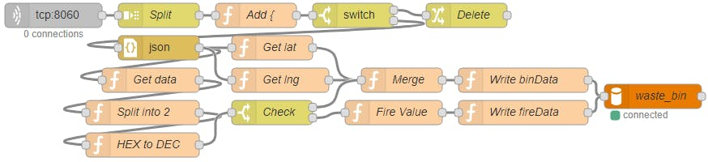

**MIT APP:**

**7.ADVANTAGES AND DISADVANTAGES:**

**ADVANTAGES:**

❖Less time and fuel consumption as the trucks go only to the filled containers

❖ Reduces the infrastructure (trucks, containers), operating (fuel) and maintenance costs of the service by up to 30%.

❖ Applying this technology to the city optimises management, resources and costs, and makes it a “SMART CITY”.

❖ Historical information on collections helps adapt the deployment of containers to the actual needs of the city, therefore reducing the number of containers that clutter up the road and increasing public parking spaces.

❖ It keeps the surroundings clean and green, free from bad odour of wastes, emphasizes on healthy environment and keep cities more beautiful.

❖ Reducing manpower required to handle the garbage collections.

**DISADVANTAGES:**

* The project is not always cost effective.
* The practice is not done uniformly.
* Garbage segregation is very difficult.

**APPLICATIONS:**

❖This can be best used by municipal corporation for their betterment of management regarding collection of wastes.

❖ With the help of proper technology (GPS & SOFTWARE APPLICATIONS) we can guide the trucks to choose the shortest path.

❖ It also favours the “SMART CITY” project and “DIGITAL INDIA”.

**CONCLUSION :**

❖ By using this method the collection of waste in the city becomes easier. It helps in reducing air pollution, traffic flow, man power, time and money. With the help of proper technology (GPS & SOFTWARE APPLICATIONS) we can guide the trucks in selecting the shortest path for garbage collection. This project can add an edge to the cities aiming to get smart and people-friendly.

**REFRENCES**

1. Glossary of Environment Statistics: Series F, No. 67 / Department for Economic and Social Information and Policy Analysis, United Nations. New York: UN, 1997.

2. *United Nations Environmental Programme (2013). "Guidelines for National Waste Management Strategies Moving from Challenges to Opportunities."*

3. *"Arduino - Introduction". arduino.cc.*

4. "Programming Arduino Getting Started with Sketches". McGraw-Hill. Nov 8, 2011.  Retrieved 2013-03-2